STUDENT ATTENDANCE ANALYTICS
@CREATIVITY THINK (9483175986/7019689991)

ABSTRACT:
Student Attendance Analytics is a web-based application designed to manage and analyze attendance records for schools, colleges, and coaching centers. The system enables accurate recording of student attendance, generation of trends, individual and class-level statistics, and timely parent notifications. Users can mark attendance, view personalized reports, and access dashboard analytics. Administrators can add classes, manage student data, oversee notifications, and track overall attendance trends. Built using Django and Django Rest Framework on the backend, and React with axios and recharts on the frontend, the platform ensures seamless data handling, insightful analytics, and real-time updates..

INTRODUCTION OF THE PROJECT:
Maintaining attendance manually in educational institutions often results in errors, inefficiencies, and lack of transparency. Teachers may find it difficult to analyze trends, notify parents, or generate meaningful reports. Student Attendance Analytics addresses these challenges by providing a centralized system for attendance recording, trend analysis, and automated notifications. With a user-friendly interface and interactive dashboards, the platform enables both educators and administrators to monitor attendance effectively, make data-driven decisions, and maintain accurate records..

PROJECT OBJECTIVES:

• Provide a centralized system for recording student attendance
• Enable users to view personal and class-level attendance statistics
• Generate trends and insights using visual dashboards
• Notify parents automatically regarding attendance
• Allow administrators to add classes and students efficiently
• Track attendance patterns for informed decision-making
• Ensure secure, scalable backend APIs for handling attendance data
• Support exportable reports for academic and administrative purposes

PROBLEM OF THE STATEMENT:
Traditional attendance management relies on paper registers or fragmented digital tools, causing errors, missed notifications, and difficulty in trend analysis. Parents lack timely updates, and administrators struggle with reporting and analytics. Student Attendance Analytics resolves these challenges by providing a digital solution that records attendance accurately, generates statistics and visual trends, and automates parent notifications, ensuring transparency, efficiency, and accountability..

MOTIVATION OF THE PROJECT:
• To replace manual attendance systems with a digital platform
• To provide accurate and reliable attendance records
• To generate class and individual performance insights
• To automate parent notifications for better engagement
• To assist administrators in monitoring trends and managing student data
• To improve decision-making using dashboards and analytics
• To enhance operational efficiency in educational institutions

BLOCK DAIGRAM OF PROJECT:

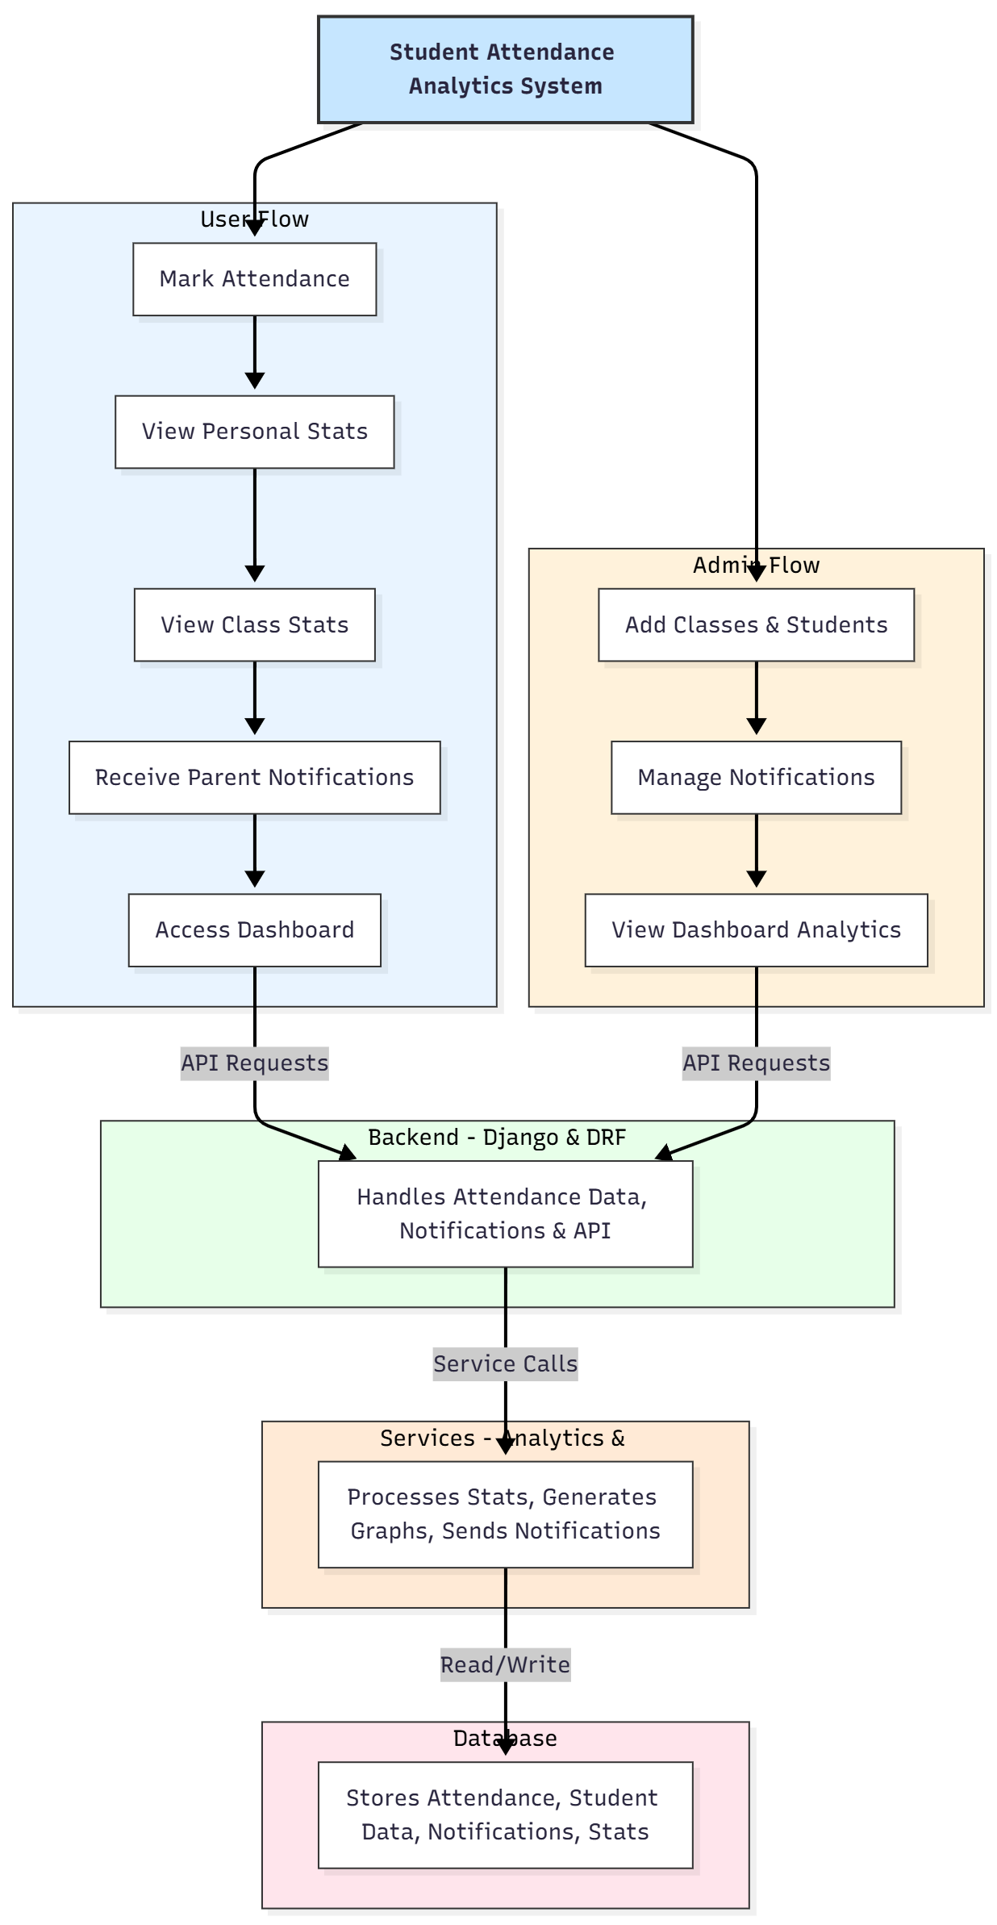

WORKING OF THE PROJECT:
The system allows teachers to mark attendance for individual students or entire classes. Attendance data is stored securely in the backend, and trends are calculated for individual and class performance. Parents receive automatic notifications regarding their child’s attendance. Administrators can add new classes, manage students, view overall analytics, and generate dashboard reports. The services module handles statistics calculation, graph generation, and notifications, while the database stores structured attendance records, student information, and notification logs. This ensures accurate, transparent, and real-time attendance management..

SOFTWARE REQUIREMENT:
- Backend:
  - Python 3.x
  - Django
  - Django REST Framework
  - SQLite/PostgreSQL
- Frontend:
  - Node.js and npm
  - React.js
  - Axios
- Development Tools:
  - Visual Studio Code
  - Postman (for testing APIs)
  - Git/GitHub (for version control)
- Server/Deployment (Optional):
  - Gunicorn, Nginx, or Heroku/AWS for hosting

ADVANTAGES OF THE PROJECT:

• Accurate and reliable attendance tracking
• Automated notifications to parents
• Visual dashboards with individual and class stats
• Reduces manual errors and paperwork
• Helps in identifying trends and performance patterns
• Improves engagement between school and parents
• Simplifies administrative tasks for educators
• Scalable for multiple classes and institutions

APPLICATIONS OF THE PROJECT:
• Schools
• Colleges
• Coaching centers
• Educational institutions requiring attendance analytics
• Parent-teacher engagement systems
• Academic performance monitoring

REFERENCES:

- Django REST Framework Documentation — Django Software Foundation. Django Documentation. Available: https://docs.djangoproject.com/
- Django REST Framework. DRF Documentation. Available: https://www.django-rest-framework.org/
- React. React Official Documentation. Available: https://reactjs.org/docs/getting-started.html
- Redux. Redux Documentation. Available: https://redux.js.org/introduction/getting-started
- PostgreSQL Global Development Group. PostgreSQL Documentation. Available: https://www.postgresql.org/docs/
- MySQL. MySQL Reference Manual. Available: https://dev.mysql.com/doc/
- Git. Git Documentation. Available: https://git-scm.com/doc
- Node.js. Node.js Documentation. Available: https://nodejs.org/en/docs/
- Axios. Axios Documentation. Available: https://axios-http.com/docs/intro
- Socket.io Documentation – https://socket.io/docs/

